PROJECT REPORT
Import Data using Transform Maps (Spreadsheet)

INTRODUCTION

Project Overview
This micro project demonstrates the end-to-end import of structured employee data from an external spreadsheet into the ServiceNow platform using Import Sets and Transform Maps. The spreadsheet acts as the external source, the Employee Import table acts as a staging area, and the Employee Test table is the target. A Transform Map connects source fields to target fields and executes the transformation. The imported records are then validated, duplicate prevention is demonstrated with Coalesce, and reports are consolidated into an Employee Analytics Dashboard.

Purpose
The purpose is to provide a practical workflow for loading bulk employee information into ServiceNow accurately and efficiently. The project covers spreadsheet preparation, target-table creation, import-set loading, field mapping, transformation, validation, duplicate prevention, repeated imports, reporting, and dashboard creation.

IDEATION PHASE

Problem Statement
Employee information may arrive in spreadsheet form and can contain many records, changes to existing employees, and repeated submissions. Manually entering or repeatedly inserting such data can cause duplicate records and reduce data consistency. The project addresses this by staging spreadsheet data in an Import Set and transforming it into a controlled ServiceNow target table.

Empathy Map Canvas
Source-derived stakeholder view: administrators/HR users receive employee data externally, need accurate imports, need to identify inserted and updated records, and need visibility into employee information. Their operational concerns are duplicate records, unsuccessful imports, and manual effort. The implemented workflow responds through Import Sets, Transform Maps, Coalesce, Transform History, reports, and a dashboard.

Brainstorming
The solution flow developed from the source process is: prepare spreadsheet → create Employee Test target table → create Employee Import staging table → create Transform Map → auto-map and assist field mapping → transform → validate → enable Coalesce → import changed/new spreadsheet data → inspect Transform History → create reports → add reports to Employee Analytics Dashboards.

REQUIREMENT ANALYSIS

Customer Journey map
A source-derived journey is: receive employee spreadsheet → prepare/download the spreadsheet → load data into Employee Import → configure source-to-target mappings → run the transformation → inspect Employee Test and Transform History → repeat imports when data changes → use Coalesce to update existing records rather than create duplicates → review reports and dashboard.

Solution Requirement
Functional requirements supported by the source are: create the Employee Test table (u_employee_test); create Employee ID, Employee Name, Email, Department and Location fields; create Employee Import (u_employee_import); create the Sample Spreadsheet Import Transform Map; map source and target fields; execute transformations; validate records; enable Coalesce; process new and changed spreadsheet rows; create Employees by Department, Employees by Location and Employee List Report; and add the reports to Employee Analytics Dashboards.

Data Flow Diagram
External spreadsheet data is loaded into the Employee Import staging table. The Transform Map maps the staged source fields to the Employee Test target table. The transformation creates or updates target records. Transform History provides import status information. The resulting employee data feeds reports and the Employee Analytics Dashboard. Coalesce provides duplicate-prevention/update behavior for repeated imports.

Technology Stack
ServiceNow platform; Import Sets / Load Data; Import Set table Employee Import (u_employee_import); target custom table Employee Test (u_employee_test); Transform Maps; Auto Map Matching Fields; Mapping Assist; Transform History; Coalesce; ServiceNow Reports; ServiceNow Dashboards; external spreadsheet/Excel source. The source does not specify external APIs, machine-learning components, or a separate application database.

PROJECT DESIGN

Problem Solution Fit
The problem is bulk employee-data migration and repeated updates from spreadsheet files. The solution fits the workflow by using a staging table for incoming data, explicit field mappings for controlled transformation, a target employee table for operational records, Coalesce for duplicate prevention, and reports/dashboard components for visibility.

Proposed Solution
The proposed solution is an automated ServiceNow employee-data import workflow. A spreadsheet is prepared and downloaded as Sample Spreadsheet.xlsx. Data is loaded through Load Data into Employee Import. The Sample Spreadsheet Import Transform Map maps the source fields to Employee Test and transforms the records. Subsequent imports can update existing records or insert new records, while repeated identical submissions can be ignored when Coalesce identifies existing records. Reports and a dashboard provide centralized visibility.

Solution Architecture
Architecture layers: Spreadsheet/Excel source → Load Data / Import Set staging → Employee Import table → Sample Spreadsheet Import Transform Map → Employee Test target table → Transform History and validation → reports (Department, Location, List) → Employee Analytics Dashboard. Coalesce operates in the Transform Map to identify existing records during repeated imports.

PROJECT PLANNING & SCHEDULING

Project Planning
The work can be organized into two sprints based on the implementation flow. Sprint 1 covers spreadsheet preparation, Employee Test creation, Employee Import creation, field setup, and Transform Map mapping.
Sprint 2 covers transformation and validation, Coalesce, repeated imports, reports, and dashboard creation.
The detailed planning logic used for this project totals 26 story points across two sprints, giving a calculated velocity of 13 story points per sprint.

FUNCTIONAL AND PERFORMANCE TESTING

Performance Testing
The source documents functional validation through successful transformation, Transform History, and repeated imports. In the demonstrated repeated-import scenario, four rows were uploaded: two new IDs were inserted and two existing IDs were updated with changed name/email values. When the same sheet was uploaded again, four rows were ignored, with zero new inserts and zero updates. These observations demonstrate the intended duplicate-prevention behavior. The source does not provide numerical latency, throughput, CPU, memory, or load-test measurements, so those performance metrics are not specified.

RESULTS

Output Screenshots
The source contains screenshots covering the Employee Import table, Transform Map, transformed
Employee Test records, Transform History, report creation, dashboard creation, and the final dashboard with three reports. Representative source pages are included below as evidence of the implemented workflow.

ADVANTAGES & DISADVANTAGES
Advantages: reduces manual entry for bulk employee data; provides a staging layer; supports explicit source-to-target field mapping; validates transformed records; Coalesce prevents redundant duplicate records during repeated imports; Transform History shows import outcomes; reports and dashboards provide centralized visibility.
Disadvantages/limitations from the source: the workflow depends on correctly prepared spreadsheet data and field mappings; configuration requires ServiceNow administrative steps; the source does not document automated external-system integration, API integration, quantified performance testing, or a productiongrade security design.

CONCLUSION
The project successfully implements an automated employee data management workflow in ServiceNow using Import Sets and Transform Maps. The process loads spreadsheet data into a staging table, maps it to the Employee Test target table, transforms and validates the records, and supports subsequent data updates. Coalesce improves data integrity by identifying existing records during repeated imports. Reports and the Employee Analytics Dashboard provide visual access to employee data and import activity.

FUTURE SCOPE
Based strictly on the demonstrated workflow, future extensions could include connecting the import process to additional external data sources, automating scheduled imports, adding more validation rules, expanding report metrics, introducing richer dashboard controls, and adding formal performance/security testing. These extensions are not implemented in the source document and are therefore presented as possible future work rather than completed features.

APPENDIX

Source Code (if any)
No source-code listing is provided in the supplied project document. The implementation is described through ServiceNow configuration and navigation steps.

Dataset Link
No external dataset link is provided. The source uses a sample Google Spreadsheet/Excel workflow and refers to Sample Spreadsheet.xlsx.
GitHub & Project Demo Link
No GitHub repository or project-demo URL is provided in the supplied source.

Representative Source Screenshots
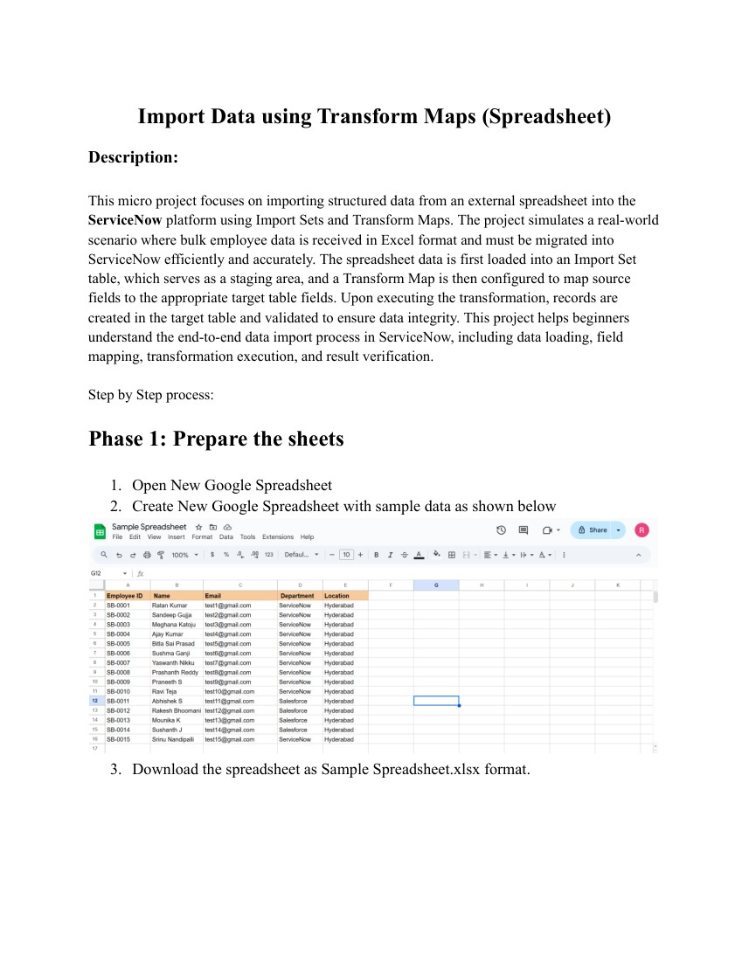
Figure 1. Source workflow screenshot (page 1).
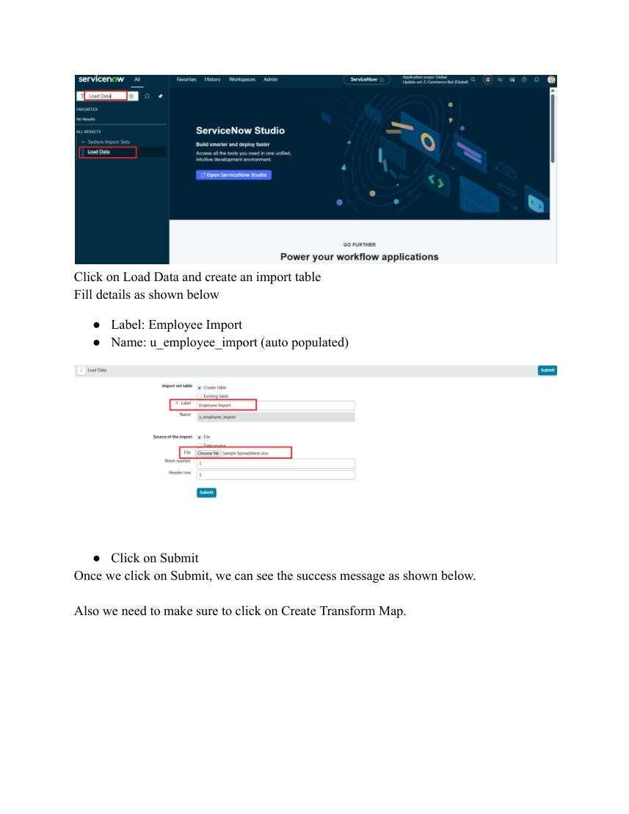
Figure 2. Source workflow screenshot (page 5).
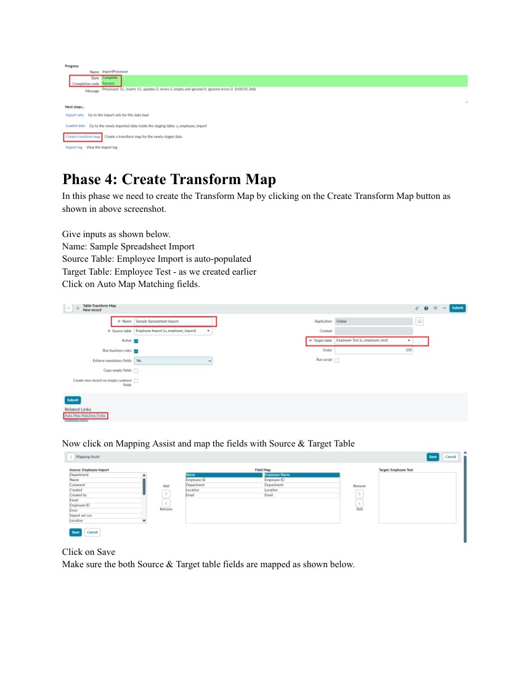
Figure 3. Source workflow screenshot (page 6).
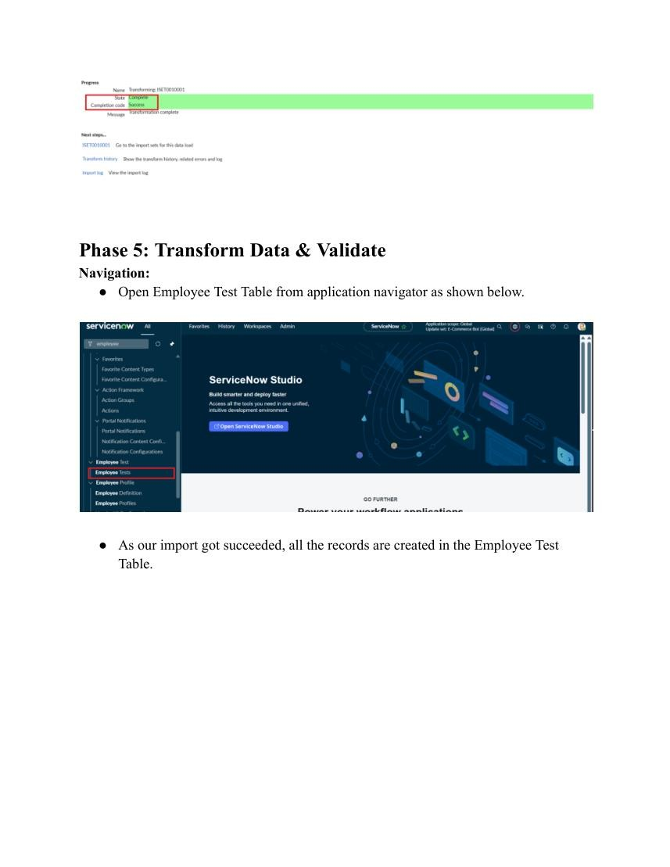
Figure 4. Source workflow screenshot (page 8).
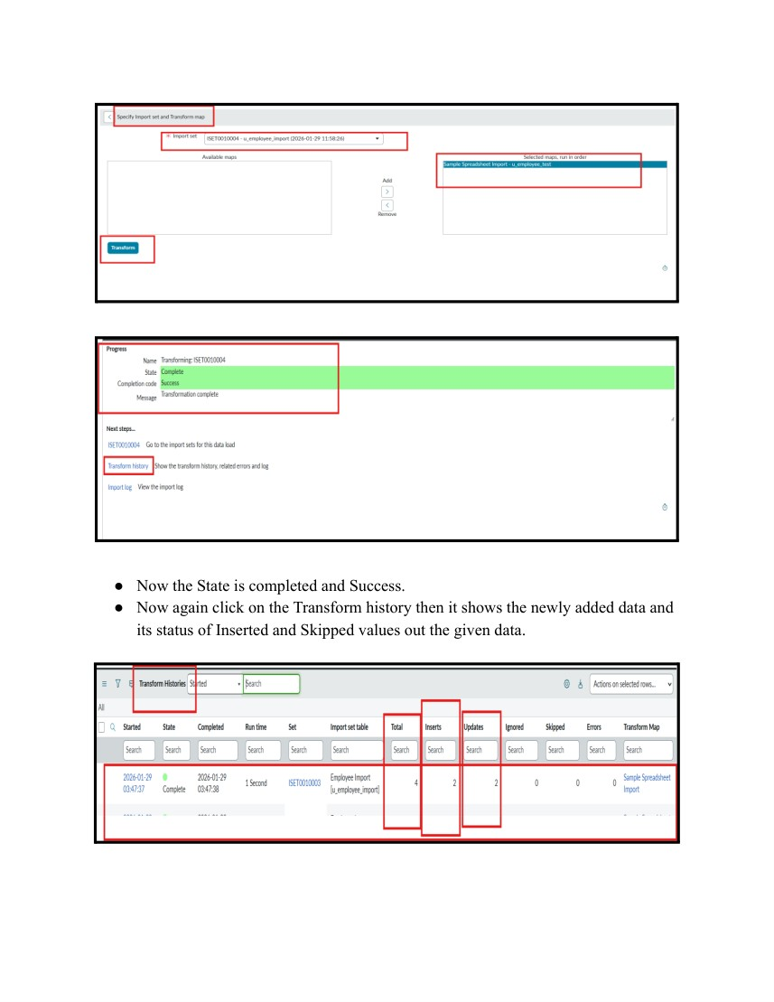
Figure 5. Source workflow screenshot (page 15).
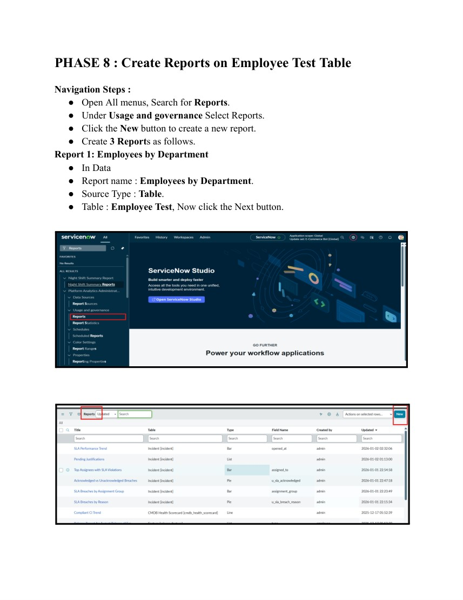
Figure 6. Source workflow screenshot (page 17).
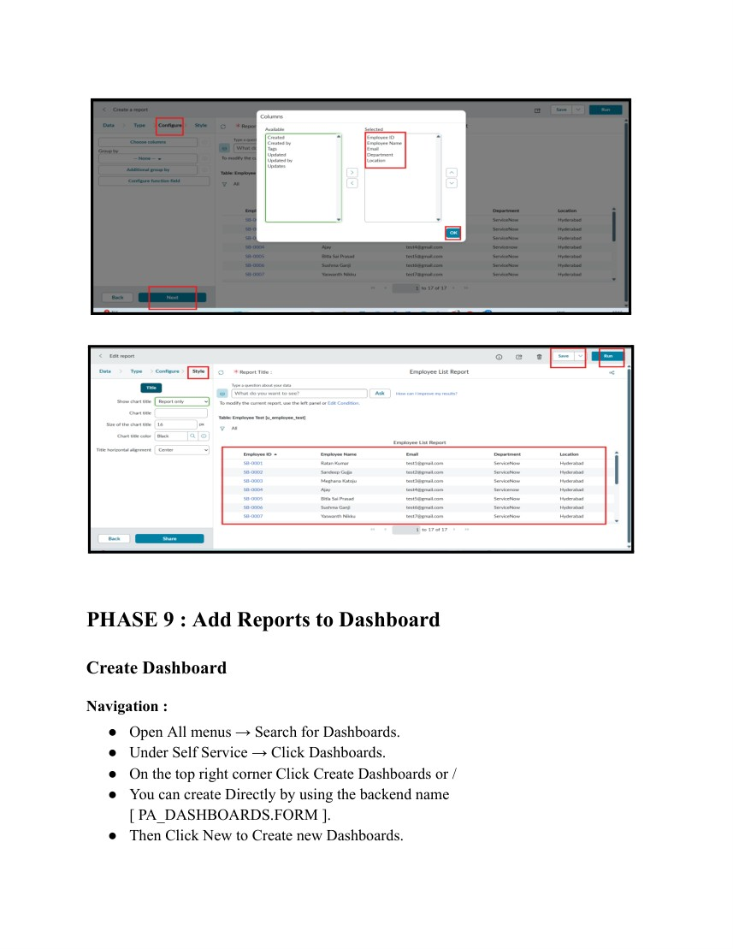
Figure 7. Source workflow screenshot (page 24).
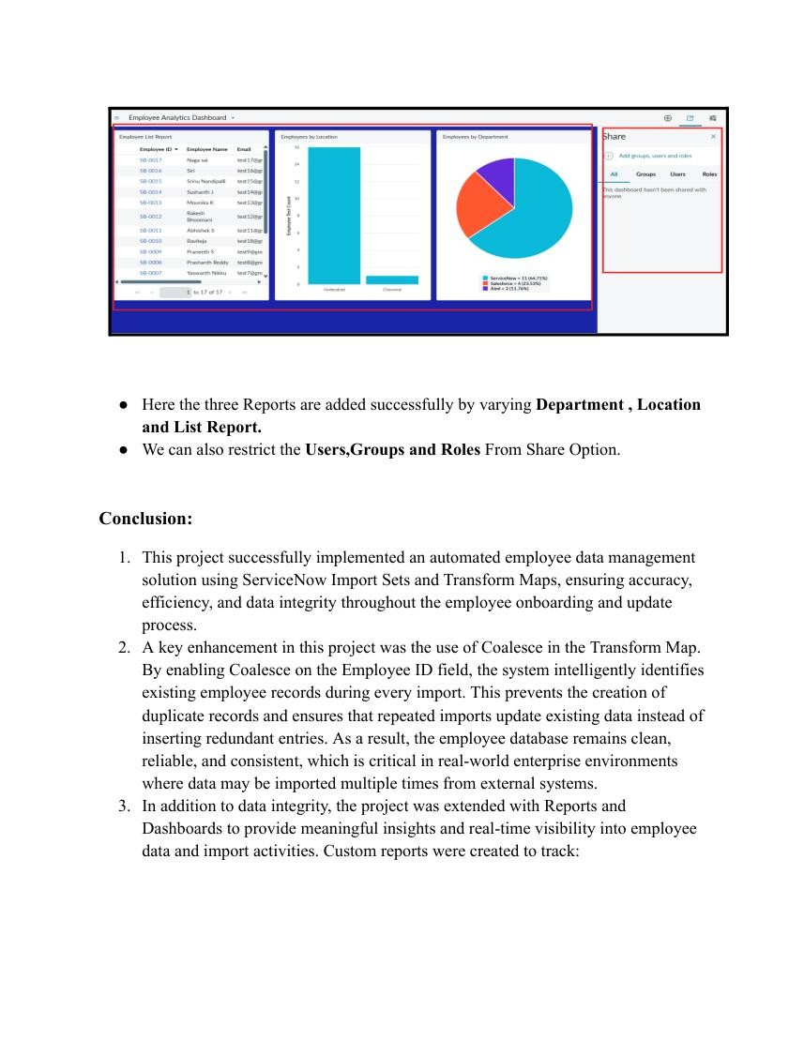
Figure 8. Source workflow screenshot (page 30).

Source basis: Import Data using Transform Maps (Spreadsheet), supplied as the project source document.
The report follows the section order of the uploaded Final Report Template.

